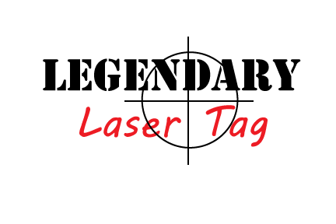
ACHNOWLEDGEMENT AND RELEASE
In consideration of Participating in the sport of “LASER TAG” I represent, that I understand the nature of the Activity and that I am qualified, in good health, and in proper physical condition to participate in such Activity. I acknowledge that if I believe event conditions are unsafe, I will immediately discontinue participating in the Activity.
I fully understand that this Activity involve risks of serious bodily injury, including permanent disability, paralysis and death, which may be caused by my own actions, or inactions, of others participating in the event, the conditions in which the event takes place, or the negligence of the “releases” named below; and that there may be other risks either not known to me or not readily foreseeable at this time; and I fully accept and assume all such risks and all responsibility for losses, costs and damages I incur as a result of my participation in the Activity.
I hereby release, discharge, and covenant not to sue Legendary Laser Tag LLC, its owners, employees, volunteers, other participants, any sponsors, advertisers, and if applicable, owners and lessors of premises on which the Activity takes place, (each considered one of the “RELEASES” herein) from all liability, claims, demands, losses, or damages on my account caused or alleged to be caused in whole or in part by the negligence or the “Releases” or otherwise, including negligent rescue operations; and I further agree that if, despite the release, waiver of liability, and assumption of risk I, or anyone on my behalf, makes a claim against any of the Releases, I will indemnify, save and hold harmless each of the releases from any loss, liability, damage, or cost which any may incur as a result of such claim.
I accept all responsibility for property damage to Legendary Laser Tag LLC’s premises, facilities, laser tag equipment and concessions caused by MY actions. I also understand the term “Legendary Laser Tag LLC’s premises and facilities” includes the leasing space in the building, all fixtures in it and the equipment associated with it.
I grant to Legendary Laser Tag LLC, its representatives and employees the right to film and/or photograph me and my property while on Legendary Laser Tag LLC’s premises. I authorize Legendary Laser Tag LLC, its assigns and transferees to copyright, use and publish the same in print and/or electronically. I agree that Legendary Laser Tag LLC may use such photographs and/or video of me with or without my name and for any lawful purpose, including for example such purposes as publicity, illustration, advertising, and web content.
I have read this ACKNOLEDGEMENT AND RELEASE. I understand that I have given up substantial rights by signing it and have signed it freely and without any inducement and assurance of any nature and intend it be a complete and unconditional release of all liability to the greatest extent allowed by law and agree that if any portion of this agreement is held to by valid the balance, notwithstanding, shall continue in full force and effect.
DO NOT SIGN THIS ACKNOWLEDGEMENT AND RELEASE UNLESS YOU HAVE READ IT AND UNDERSTAND IT. IF YOU DON’T UNDERSTAND IT, ASK A LEGENDARY LASER TAG LLC REPRESENTATIVE FOR ASSISTANCE.
Printed name of participant:_______________________________________________________________________
Participant signature:________________________________________________ Date:_______________
Phone #:__________________________________
PARENTAL CONSENT (Required for participants under the age of 18)

